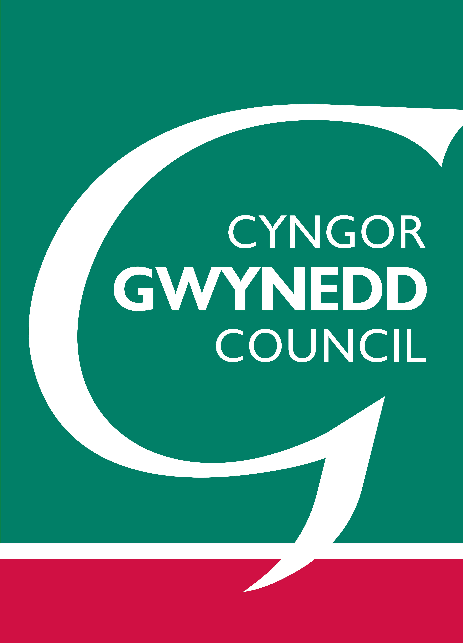 | 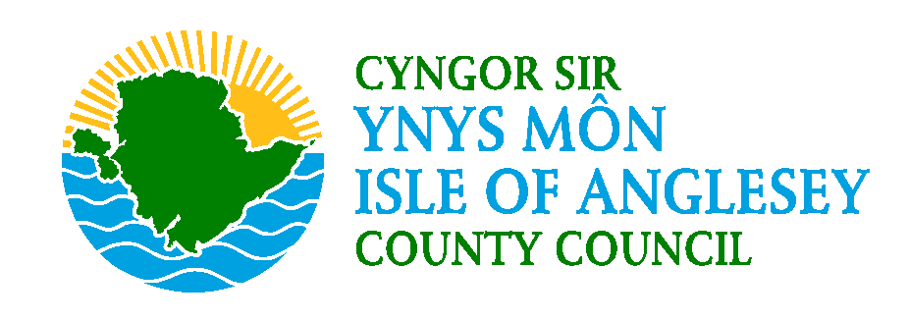 | Defnydd swyddfa yn unig/ Office use only  Rhif Cyn./Rep No.:  Derbyniwyd/Received:  Cydnabod/Acknowledged

Cynllun Datblygu Lleol ar y Cyd Adnau Ynys Môn a Gwynedd 2011-2026
FFURFLEN SYLWADAU NEWIDIADAU Â FFOCWS/
Anglesey and Gwynedd Deposit Joint Local Development Plan 2011-2026
FOCUSSED CHANGES COMMENTS FORM
25/2/16.

 | Yn dilyn ymgynghoriad ar y Cynllun Datblygu Lleol ar y Cyd arAdnau, mae Cynghorhau Gwynedd a Môn yn cynnig rhai ‘Newidiadau â Ffocws.’ Hoffem glywed eich barn ar y rhain.  Dylid defnyddio’r ffurflen hon ar gyfer yr holl sylwadau (h.y. sylwadau neu wrthwynebiadau). Mae fersiynau Uniongyrchol Ar-lein/Electronig a nodiadau cyfarwyddyd ar gael ar www.gwynedd.llyw.cymru/cdll neu www.anglesey.gov.uk/cdll . Os ydych yn cyflwyno copi ar bapur, dylech atodi tudalennau ychwanegol lle bod angen. Dylech lenwi ffurflenni ar wahân ar gyfer pob sylw yr hoffech ei wneud.  Sylwer bod RHAID i sylwadau fod yn ymwneud â’r Newidiadau â Ffocws yn unig, ac nid i agweddau eraill ar y Cynllun Datblygu Lleol ar y Cyd ar Adnau. Ni fydd sylwadau eraill yn derbyn sylw.  Mae’n rhaid derbyn eich sylwadau ddim hwyrach na 4.30yh ar yr 13 Ebrill 2016. NI FYDD SYLWADAU A DDERBYNNIR WEDI’R DYDDIAD YMA YN CAEL EU HYSTYRIED  Dychwelwch y ffurflenni at: Uned Polisi Cynllunio ar y Cyd, Swyddfa Cyngor Dinas Bangor, Ffordd Gwynedd, Bangor, Gwynedd, LL57 1DT neu polisicynllunio@gwynedd.gov.uk  Diogelu Data - Mae gan y ffurflen hon ddwy ran: Rhan A (Manylion Personol) a Rhan B (Eich sylw). Sylwer mai Rhan B yn unig fydd ar gael i’r cyhoedd a chaiff ei hanfon at yr Arolygiaeth Gynllunio.  Mae’n bosib derbyn ffurflenni sylwadau ychwanegol gan yr Uned Polisi Cynllunio ar y Cyd drwy ffonio 01286 685003 neu gellir eu llawr lwytho o wefan y Cyngor yn: www.gwynedd.llyw.cymru/cdll neu www.ynysmon.gov.uk/cdll neu gallwch lungopïo’r ffurflen hon. Wrth wneud sylwadau, defnyddiwch dudalennau ychwanegol os oes angen, gan nodi rhif y dudalen yn glir. |  | Following consultation on the Deposit Joint Local Development Plan (LDP), Anglesey and Gwynedd Councils are proposing some ‘Focussed Changes’. We would like your views on these.  This form should be used for all representations (i.e. comments or objections). Direct Online/Electronic versions and guidance notes are available at www.gwynedd.llyw.cymru/ldp or www.anglesey.gov.uk/ldp. If you are submitting a paper copy, attach additional sheets as necessary. Separate forms should be completed for each comment that you wish to make.  Please note that representations MUST relate only to the Focussed Changes, and not to other aspects of the Deposit Joint Local Development Plan. Other representations will be disregarded.  Your representations must be received by no later than 4.30pm on the 13 April 2016. REPRESENTATIONS RECEIVED AFTER THIS TIME WILL NOT BE CONSIDERED  Please return forms to: Joint Planning Policy Unit, Bangor City Council Offices, Ffordd Gwynedd, Bangor, Gwynedd, LL57 1DT or planningpolicy@gwynedd.gov.uk  Data Protection - This form has two parts: Part A (Personal details) and Part B (Your representation). Please note that only Part B will be made publicly available and will be forwarded to the Planning Inspectorate.  Additional representation forms can be obtained from the Joint Planning Policy Unit on 01286 685003 or may be downloaded from the Council’s web site at: www.gwynedd.llyw.cymru/ldp or www.anglesey.gov.uk/ldp or you may photocopy this form. When making comments please use additional sheets as required clearly numbering each consecutive sheet.
RHAN A/PART A:
Manylion cyswllt (Ni fydd y hwn ar gael yn gyhoeddus):
Contact details (This will not be made publically available):
 |  | Eich manylion neu manylion eich cleient  Your details or your client’s details |  | Manylion yr Asiant (os yn berthnasol)  Agent’s details (If relevant)
Enw
Name
Sefydliad (os yn berthnasol
Organisation (If relevant)
Cyfeiriad
Address

Côd Post
Postcode
Ffôn
Tel:
E-bost
Email:
Llofnodwyd
Signed
Dyddiad
Date

Rhowch eich sylwadau yn Rhan B y ffurflen hon. Defnyddiwch dudalennau ychwanegol os oes angen.  Dylech lenwi ffurflenni ar wahân ar gyfer pob sylw yr hoffech ei wneud.  Os yw grŵp yn rhannu barn gyffredin ynghylch Newid â Ffocws, bydd y Cynghorau’n derbyn deiseb wedi’i llofnodi. Wrth gyflwyno ffurflen sylwadau ar ran grŵp, dylai’r ffurflen sylwadau gynnwys manylion cyswllt unigolyn arweiniol yn Rhan A a dylid nodi’r sylwadau’n glir ar y ffurflen sylwadau. Dylai’r ddeiseb sydd wedi’i llofnodi nodi’n glir faint o bobl sy’n cael eu cynrychioli a sut mae’r sylwadau wedi’u hawdurdodi. Nid yw llofnodi deiseb yn atal neb rhag cyflwyno ffurflenni unigol. | Please set out your comments in Part B of this form. Use additional sheets of paper where necessary.  Separate forms should be completed for each comment that you wish to make.  Where a group shares a common view on a Focussed Change, the Councils will accept a signed petition. In submitting a representation form on behalf of a group, the representation form should include the contact details of a lead individual at Part A and the comments should be clearly set out on the representation form. The signed petition should state clearly how many people are being represented and how the representation has been authorised. Signing a petition does not prevent the submission of individual forms.

Defnydd swyddfa yn unig/ Office use only

Rhif Cyn./Rep No.:

Derbyniwyd/Received:

Cydnabod/Acknowledged

Cynllun Datblygu Lleol ar y Cyd Adnau Ynys Môn a Gwynedd 2011-2026
FFURFLEN SYLWADAU NEWIDIADAU Â FFOCWS/
Anglesey and Gwynedd Deposit Joint Local Development Plan 2011-2026
FOCUSSED CHANGES COMMENTS FORM
25/2/16.

RHAN B: Eich Sylwadau a Newidiadau a Awgrymir
PART B: Your Comments and Suggested Changes
Eich enw/Sefydliad:
Your name/Organisation:
1. Ar ba Newid â Ffocws yr ydych chi’n gwneud sylwadau? (Cofiwch defnyddio un ffurflen ar gyfer pob cynrychiolaeth)
1. Which Focussed Change are you commenting on? (Remember to use one form for each representation)
Rhif y Newid â Ffocws (NF)  Focussed Change Number (NF) |  |  | Cefnogi/ Support |  |  | Gwrthwynebu/ Object
2. Cyn i chi esbonio eich sylwadau’n fanwl, byddai’n dda gwybod os ydych yn credu fod y Cynllun yn gadarn a’i pheidio , o ganlyniad i’r Newidiadau â Ffocws, neu a ydych o’r farn bod rhannau ohono neu bob rhan ohono ddim yn gadarn a bod angen ei newid.
I gael rhagor o wybodaeth am gadernid a gofynion gweithdrefnol, gweler y nodiadau cyfarwyddyd. Os ydych yn ansicr, gadewch y rhan yma yn wag.
2. Before you set out your comments in detail, it would be helpful to know whether you think that, as a result of the Focussed Changes, the Plan is sound or that all or parts of it are unsound.
For more information on soundness and procedural requirements, see the guidance notes. If you are unsure, leave this section blank.
Cadarn/Sound |  |  |  | Dim yn gadarn ac dylid ei newid/Unsound and should be changed
3. Rhowch fanylion eich sylwadau ar y Newid â Ffocws yn y blwch nesaf.
Esboniwch pam rydych yn gwrthwynebu neu’n cefnogi’r Newid â Ffocws a nodir a pha newidiadau sydd eu hangen i’r Newid â Ffocws i wneud y Cynllun yn gadarn. Dylech gynnwys yr holl wybodaeth, tystiolaeth a gwybodaeth ategol sy’n angenrheidiol i gefnogi eich sylw. Bydd hyn yn helpu’r Awdurdod a’r Arolygydd i ddeall y materion y byddwch yn eu codi. Ni fyddwch yn gallu cyflwyno rhagor o wybodaeth i’r Archwiliad dim ond os bydd yr Arolygydd yn eich gwahodd i wneud hynny.
3. Please provide details of your representation on the Focussed Change in the next box.
Explain why you object to or support the identified Focussed Change and outline what changes are needed to the Focussed Change to make the Plan sound. Include all the information, evidence and supporting information necessary to support your representation. This will help the Authority and the Inspector to understand the issues you raise. You will only be able to submit further information to the Examination if the Inspector invites you to do so.
Defnyddiwch dudalennau ychwanegol os bydd angen.
Nodwch faint o dudalennau ychwanegol rydych wedi’u defnyddio..........
Please use additional sheet if necessary.
Please state how many additional sheets have been used…….…

4. Os yw eich sylw yn 3 yn fwy na 100 o eiriau, darparwch grynodeb os gwelwch yn dda (dim mwy na 100 o eiriau.
4. If your response to 3 above exceeds 100 words, please provide a summary (no more than 100 words).
5. A ydych am i’ch sylwadau gael eu hystyried fel ‘sylwadau ysgrifenedig' neu a hoffech siarad mewn sesiwn gwrandawiad yn yr Archwiliad Cyhoeddus? (Ticiwch un o’r isod)
Ar y cam hwn, gallwch wneud sylwadau’n ysgrifenedig yn unig (gelwir y rhain yn 'sylwadau ysgrifenedig'). Fodd bynnag, gall pawb sydd am newid y Cynllun ymddangos gerbron yr Arolygydd a siarad mewn ‘sesiwn gwrandawiad’ yn ystod yr Archwiliad Cyhoeddus. Ond dylech gofio y bydd yr Arolygydd yn rhoi’r un pwysau ar eich sylwadau ysgrifenedig ar y ffurflen hon â’r rheiny a wneir ar lafar mewn sesiwn gwrandawiad. Sylwer, bydd yr Arolygydd yn dewis y weithdrefn fwyaf priodol er mwyn darparu ar gyfer y rhai sydd eisiau rhoi tystiolaeth lafar.

5. Do you want your comments to be considered by ‘written representations’ or do you want to speak at a hearing session of the Public Examination? (Please tick one of the following)
At this stage, you can only make comments in writing (these are called 'written representations'). However, everyone that wants to change the Plan can appear before and speak to the Inspector at a ‘hearing session’ during the Public Examination. But you should bear in mind that your written comments on this form will be given the same weight by the Inspector as those made verbally at a hearing session. Please note that the Inspector will determine the most appropriate procedure for accommodating those who want to provide oral evidence.

Nid wyf am siarad mewn sesiwn gwrandawiad ac rwyf yn fodlon i'm sylwadau ysgrifenedig gael eu hystyried gan yr Arolygydd.
I do not want to speak at a hearing session and am happy for my written comments to be considered by the Inspector.
Hoffwn siarad mewn sesiwn gwrandawiad.
I want to speak at a hearing session.
6. Os hoffech siarad, cadarnhewch pam rydych yn ystyried ei bod hi’n angenrheidiol i chi siarad yn y Gwrandawiad.

6. If you wish to speak, please confirm which part of your representation you wish to speak to the Inspector about and why you consider it to be necessary to speak at the Hearing.

7. Os ydych am siarad, byddai’n ddefnyddiol pe gallech nodi ym mha iaith hoffech chi gael eich clywed? (Ticiwch un o’r isod)
6. If you wish to speak, it would be helpful if you could indicate in which language you would like to be heard. (Please tick one of the following boxes)

Hoffwn i gael fy nghlywed yn Gymraeg
I wish to be heard in Welsh
Hoffwn i gael fy nghlywed yn Saesneg
I wish to be heard in English

DIOLCH AM EICH SYLWADAU AM Y NEWIDIADAU Â FFOCWS/ THANK YOU FOR YOUR COMMENTS ON THE FOCUSSED CHANGES

Nodiadau cyfarwyddyd | Guidance notes
Bydd Cynllun Datblygu Lleol Gwynedd a Môn ar y Cyd yn cael ei archwilio gan Arolygydd annibynnol a benodir gan Lywodraeth Cymru. Gwaith yr Arolygydd yw ystyried a yw’r Cynllun yn bodloni gofynion gweithdrefnol ac a yw’n gadarn.  Gellir ystyried ‘Cadarn’ yn y cyd-destun hwn o fewn ei ystyr arferol o ‘dangos barnu da’ a ‘gellir ymddiried ynddo’. Y cwestiynau neu’r ‘profion’ y bydd yr Arolygydd yn eu hystyried wrth benderfynu a yw’r Cynllun yn gadarn yw:  1. A yw’r cynllun yn ffitio? (h.y. a yw’n gyson â chynlluniau eraill?)  2. A yw’r cynllun yn briodol? (h.y. a yw’n briodol ar gyfer yr ardal yng ngoleuni’r dystiolaeth?)  3. A fydd y cynllun yn cyflawni? (h.y. a yw’n debygol o fod yn effeithiol?)  Darperir rhagor o wybodaeth am y profion cadernid a’r gofynion gweithdrefnol yn Arweiniad Gweithdrefnol ar Archwiliadau Cynllun Datblygu Lleol yr Arolygiaeth Gynllunio.  Wedi ymgynghori ar fersiwn adneuo'r Cynllun Datblygu Lleol, mae Cynghorau Gwynedd a Môn yn gwneud nifer gyfyngedig o Newidiadau â Ffocws er mwyn gwneud y Cynllun yn gadarn cyn iddo gael ei archwilio. Ymgynghorir ar y newidiadau rwan. Caiff unrhyw ymatebon eu hanfon ymlaen yn uniongyrchol at yr Arolygydd Cynllunio.  Os ydych yn gwrthwynebu Newid â Ffocws, dylech ddweud pam nad yw’n gwneud y Cynllun yn gadarn a sut dylid newid y Newid â Ffocws er mwyn gwneud y Cynllun yn gadarn.  Lle rydych yn cynnig newid i ‘r Newid â Ffocws byddai’n ddefnyddiol egluro pa brawf (profion) cadernid rydych yn credu ei fod yn methu. Fydd methu adnabod prawf ddim yn golygu na chaiff eich sylw ystyriaeth, cyn belled â’i fod yn ymwneud a’r Newidiadau â Ffocws. Dylech gynnwys eich holl sylwadau ar y ffurflen, gan ddefnyddio dogfennau ychwanegol a thystiolaeth ategol lle bod angen. | The Joint Anglesey and Gwynedd Local Development Plan (LDP) will be examined by an independent Inspector appointed by the Welsh Government. It is the Inspector’s job to consider whether the Plan meets procedural requirements and whether it is sound.  ‘Sound’ may be considered in this context within its ordinary meaning of ‘showing good judgement’ and ‘able to be trusted’. The questions or 'tests' which the Inspector will consider in deciding whether the Plan is sound are:  1. Does the plan fit? (i.e. is it consistent with other plans?)  2. Is the plan appropriate? (i.e. is it appropriate for the area in the light of the evidence?)  3. Will the plan deliver? (i.e. is it likely to be effective?)  More information on the soundness tests and procedural requirements is provided in the Planning Inspectorate’s Local Development Plan Examinations Procedural Guidance.  Having consulted on the Deposit version of the Local Development Plan, Anglesey and Gwynedd Councils are making a limited number of ‘Focussed Changes’ to make the Plan sound before it is examined. These changes are being consulted upon now. Any responses will be forwarded directly to the Planning Inspector.  If you are objecting to a Focussed Change, you should say why you think it makes the Plan unsound, and how the Focussed Change should be amended to make the Plan sound.  Where you propose an amendment to a Focussed Change it would be helpful to make clear which test(s) of soundness you believe it fails. Failing to identify a test will not mean that your comment will not be considered, providing it relates to the Focussed Changes. You should include all your comments on the form, using accompanying documents and supporting evidence where necessary.
Dychwelwch y ffurflen i: Uned Polisi Cynllunio ar y Cyd, Swyddfa Cyngor Dinas Bangor, Ffordd Gwynedd, Bangor, Gwynedd, LL57 1DT neu polisicynllunio@gwynedd.gov.uk erbyn 4.30yh ar 13/4/16 | Please return the form to: Joint Planning Policy Unit, Bangor City Council Offices, Ffordd Gwynedd, Bangor, Gwynedd, LL57 1DT or planningpolicy@gwynedd.gov.uk by 4.30pm on 13/4/16

