Cyllid / Finance

Gwasanaeth Budd-dal / Benefits Service
Cinio Ysgol am Ddim / Free School Meals
Cais / Application 2023

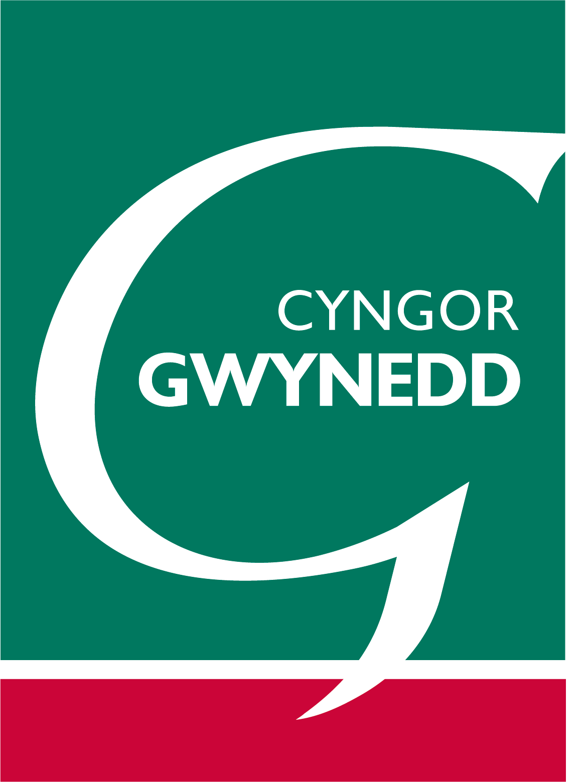

1. MANYLION Y RHIANT/GWARCHEIDWAD / PARENT/GUARDIAN DETAILS
Teitl – Mr/Mrs/Miss/Ms/Arall/Other  Title |  | Cyfeiriad  Address
Cyfenw/
Surname
Enw(au)cyntaf
First name(s)
Dyddiad Geni
Date of Birth
Perthynas i’r plentyn
Relationship to child
Rhif ffôn  Telephone Number |  | Côd Post  Post Code
2. MANYLION Y PLENTYN / CHILD DETAILS
Enw Llawn / Full Name | Dyddiad Geni / DOB | Ysgol / School | Rhyw / Gender

3. AMODAU CYMHWYSO / QUALIFYING CONDITIONS
Cadarnhaf fy mod yn derbyn un o’r canlynol / I confirm that I receive one of the following ( ✓ )

Cymhorthdal Incwm / Income Support Credyd Treth Plant / Child Tax Credit (Gweler trosodd
/ See over)
Lwfans Ceisio Gwaith (sail incwm) / Job Seekers Allowance (income based)

Lwfans Cymorth a Chyflogaeth (sail incwm) / Employment and Support Allowance (income based)

Credyd Cynhwysol gyda incwm enillir net blynyddol llai na £7,400 / Universal Credit with a net annual earned income less than £7,400

Credyd Pensiwn (Gwarant) / Pension Credit (Guarantee)

Cymorth o Dan Ddeddf Lloches a Mewnfudo 1999 / Help under Immigration and Asylum Seekers Act 1999

Fy rhif Yswiriant Cenedlaethol yw / My National Insurance number is :

4. DATGANIAD / DECLARATION
Cytunaf i chi ddefnyddio’r wybodaeth a roddais i brosesu fy nghais am brydau ysgol am ddim, ac i gysylltu â ffynonellau eraill fel a ganiateir gan y gyfraith i wirio fy hawliad gwreiddiol a chyfredol. Deallaf y gellir defnyddio canlyniadau unrhyw archwiliad ynglŷn â hawl i dderbyn cinio am ddim i asesu fy hawl i dderbyn grant gwisg ysgol.

I agree that you will use the information I have provided to process my claim for free school meals, and will contact other sources as allowed by law to verify my initial, and ongoing entitlement. I understand that the results of any free school meals eligibility check may also be used to assess my entitlement to receive school uniform grant.

Tystiaf fod y wybodaeth yma’n gywir, ac mai fi yw rhiant/gwarcheidwad cyfreithiol y plentyn/plant a enwir uchod
I certify that the information given is correct and that I’m the parent/legal guardian of the child(ren) named above

Arwyddwyd /  Signed | Dyddiad /  Date

Dychweler y ffurflen wedi’i chwblhau at / Send the completed form to:
Swyddfa Budd-daliadau Gwynedd, Swyddfa’r Cyngor, Stryd y Jêl, Caernarfon, Gwynedd, LL55 1SH

GWYBODAETH AM CINIO AM DDIM
- Mae cinio am ddim ar gael i blant ysgolion cynradd ac uwchradd (dim i fyfyrwyr colegau) sydd â rhieni neu warcheidwad sy’n derbyn un o’r budd-daliadau canlynol.
● Lwfans Cymorth a Chyflogaeth (sail incwm)
- Cymhorthdal Incwm
- Lwfans Ceisio Gwaith (sail incwm)
- Credyd Cynhwysol ar yr amod bod gan yr aelwyd incwm a enillir net blynyddol o ddim mwy na £7,400
- Credyd Treth Plentyn (gydag incwm trethadwy blynyddol ddim mwy na £16,190)
- Credyd Pensiwn (Gwarant)
- Cymorth o Dan Ddeddf Lloches a Mewnfudo 1999

Nid yw teuluoedd sy’n derbyn Credyd Treth Gwaith yn teilyngu hyd yn oed os yw eu hincwm blynyddol o dan £16,190.

- Defnyddir gwefan FSM i wirio eich budd-daliadau ac i dderbyn cadarnhad eich bod yn deilwng i dderbyn cinio am ddim. Nid oes angen tystiolaeth gan y Ganolfan Waith na Chyllid a Thollau EM, ond mae’n hanfodol bod y rhiant/gwarcheidwad sy’n derbyn y budd-dal uchod yn rhoi eu dyddiad geni a rhif yswiriant gwladol ar y ffurflen gais hon er mwyn i ni allu gwirio’r hawl.
- Eich cyfrifoldeb chi yw hysbysu’r Swyddfa Budd-daliadau am unrhyw newidiadau yn eich amgylchiadau cyllidol/teuluol. Os byddwch yn methu gwneud hyn, bydd yr Awdurdod yn adennill unrhyw ordaliad.
4. Unwaith bydd eich cais wedi ei ganiatáu, bydd yn ddilys hyd at ddiwedd y flwyddyn ysgol oni bai bydd newid mewn amgylchiadau.
5. Rhaid i’ch plentyn fynychu ysgol yng Ngwynedd i hawlio cinio am ddim gan yr Awdurdod yma. Os ydych yn byw yng Ngwynedd a’ch plentyn / plant yn mynychu ysgol mewn Sir gyfagos e.e. Ynys Môn, yna rhaid hawlio cinio am ddim gan yr Awdurdod hwnnw.
6. Os yw eich plentyn/plant yn symud ysgol yn ystod blwyddyn ysgol bydd angen cysylltu â’r Swyddfa Budd-daliadau fel y gallant hysbysu’r ysgol newydd fod eich plentyn/plant yn deilwng i ginio am ddim.
7. Mae angen adnewyddu eich cais yn flynyddol, ac mae ffurflenni ar gael o’r ysgol neu gan y Swyddfa Budd-daliadau.
8. Gofynnir i chwi gwblhau un ffurflen yn unig, gan restru eich plant a’r ysgolion a fynychir. Nid oes angen ffurflen ar wahân os yw eich plant yn mynychu gwahanol ysgolion.

FREE SCHOOL MEALS INFORMATION
- Free school meals are available to all primary and secondary school children (not to college students) whose parents or guardians are in receipt of the following benefits.
- Employment and Support Allowance (income based)
- Income Support
- Job Seekers Allowance (income based)
- Universal Credit provided your household has an annualised net earned income of no more than £7,400
- Child Tax Credit (with annual taxable income not exceeding £16,190)
- Pension Credit (Guarantee)
- Help under Immigration and Asylum Seekers Act 1999

Families in receipt of Working Tax Credit are not eligible even if their annual taxable income is less than £16,190.

- Your benefits are verified and confirmation of your eligibility to free school meals will be obtained from the FSM website. No proof is required from the Job Centre Plus or HM Revenues & Customs, however, it is essential the date of birth and national insurance number details of the parent/guardian who receives the above benefit is provided on this application form so that we can verify eligibility.
- It is your responsibility to notify the Benefits office of any changes to financial/family circumstances. Failure to notify will result in the Authority recovering any overpayment.
- Once your application has been granted, it will be valid until the end of the school year unless there is a change in your circumstances.
- Your child must attend a school in Gwynedd to claim free school meals from this Authority. If you live in Gwynedd but your child(ren) attend(s) a school in another County, e.g. Anglesey, you must claim free school meals from that Authority.
- If your child/children move to a different school during the school year, you must contact the Benefits Office who will then inform the school that your child/children are entitled to free school meals.
- It is required to renew your application annually, forms available from the school or from the Benefits Office.
- It is required to complete one form per family by listing your children and the different schools attended. Do not complete separate forms if your children attend different schools.

YMHOLIADAU/ENQUIRIES :
 01286 682689
 budd-daliadau@gwynedd.llyw.cymru
 benefit@gwynedd.llyw.cymru

