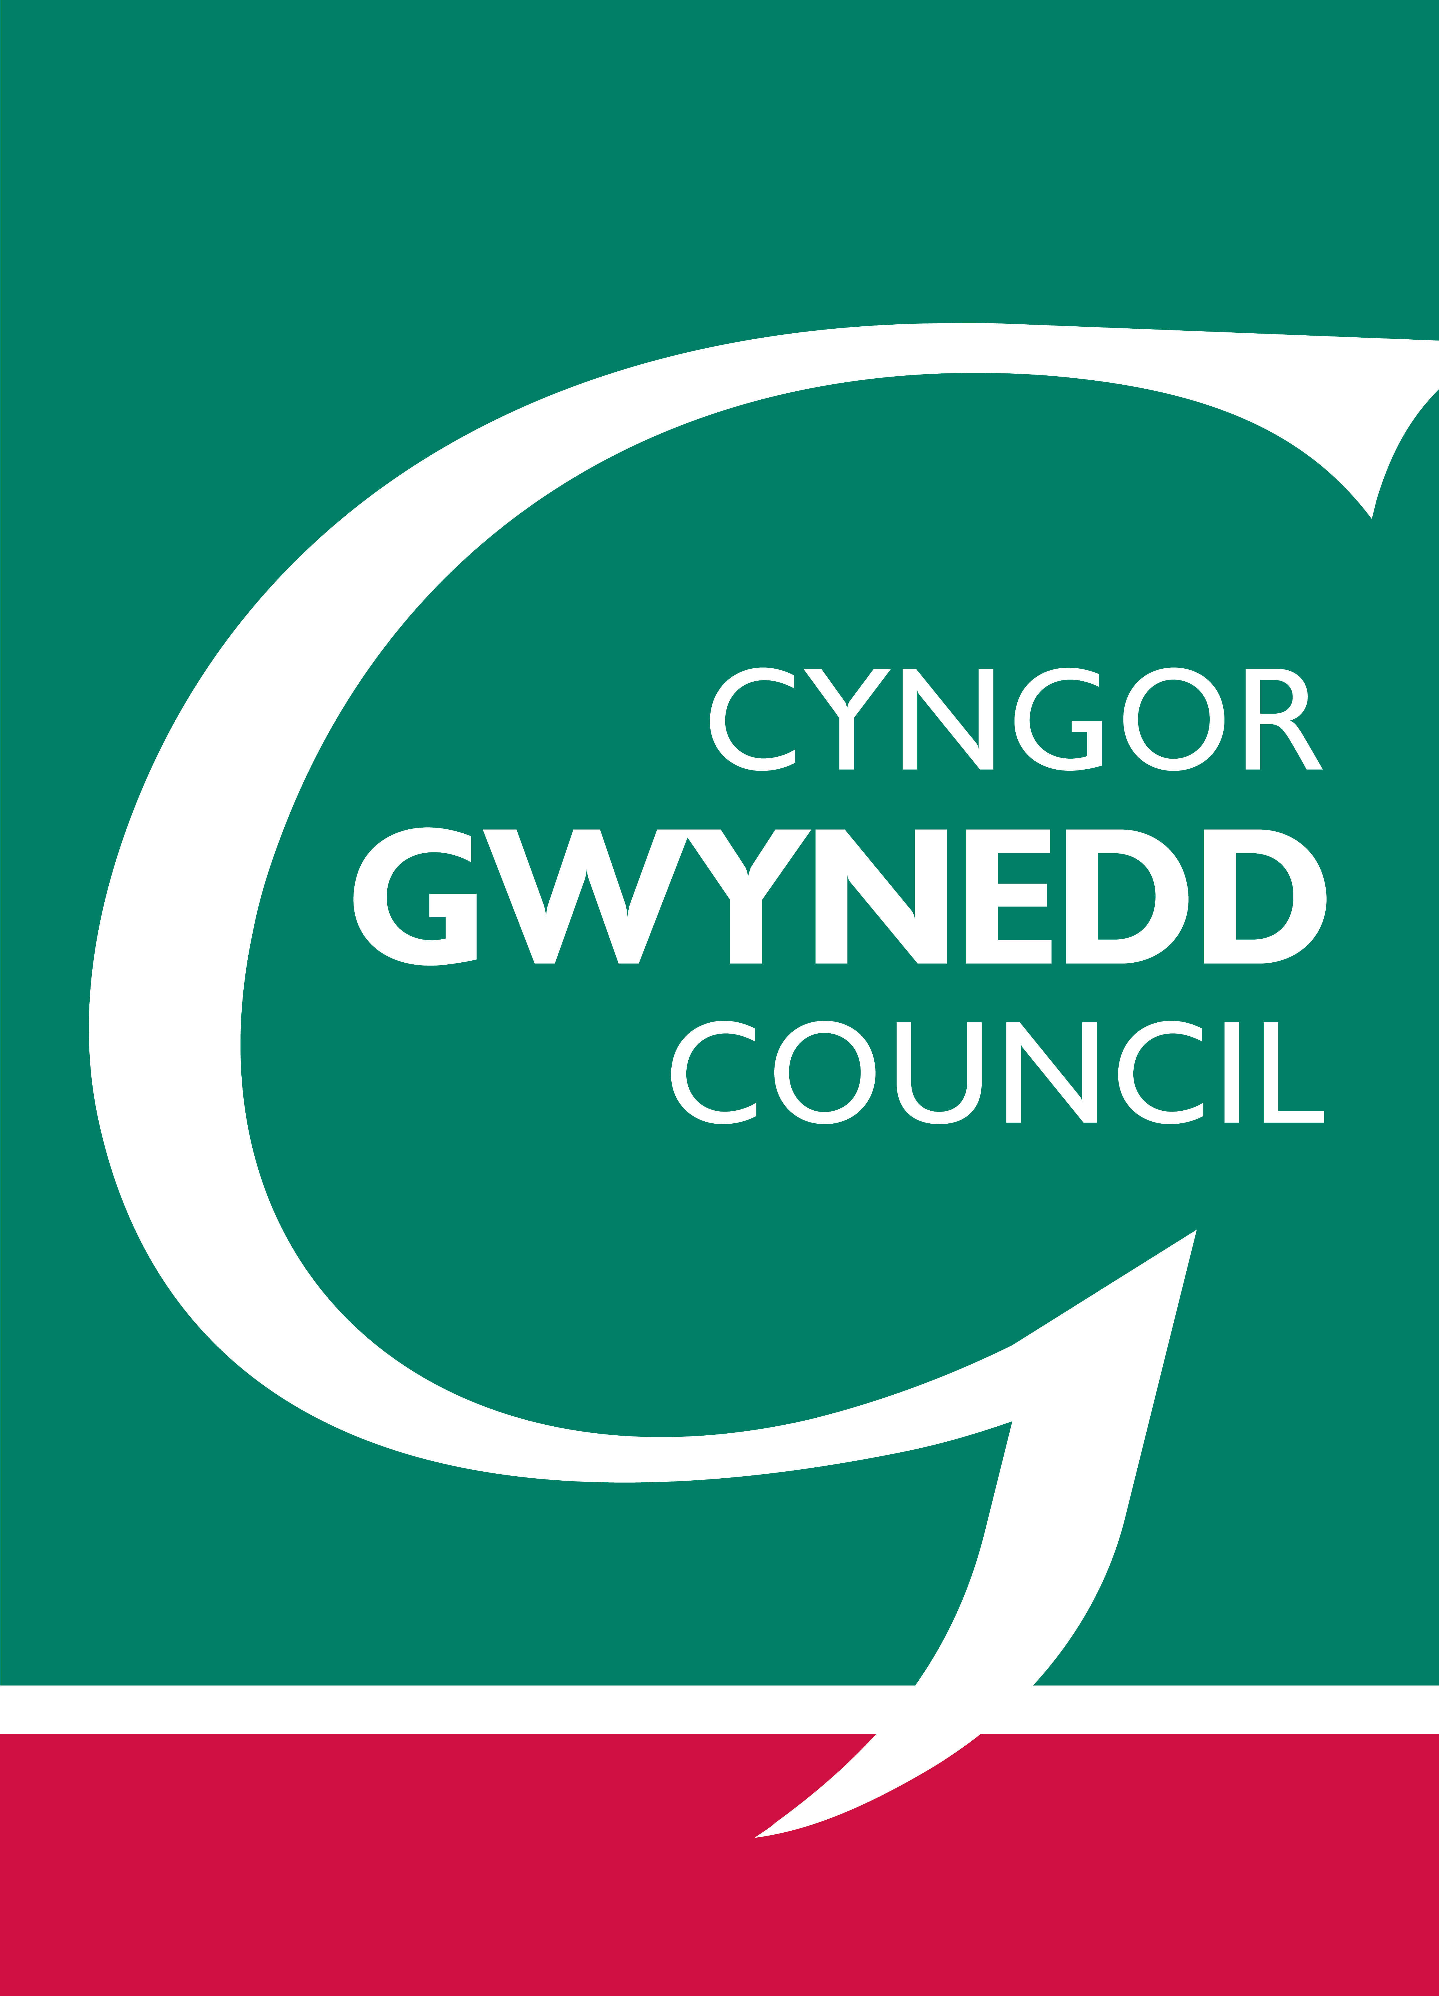 | 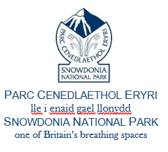 | Defnydd swyddfa yn unig/ Office use only  Rhif Cyn./Rep No.:  Derbyniwyd/Received:

Cynllun Datblygu Lleol ar y Cyd Ynys Môn a Gwynedd 2011-2026
Cynllun Datblygu Lleol Eryri 2016-2031
FFURFLEN SYLWADAU CANLLAW CYNLLUNIO ATODOL (DRAFFT YMGYNGHOROL) /
Anglesey and Gwynedd Joint Local Development Plan 2011-2026
Eryri Local Development Plan 2016-2031
SUPPLEMENTARY PLANNING GUIDANCE (CONSULTATION DRAFT) COMMENTS FORM

 | Yn dilyn yr arysgrif lwyddiannus o Dirwedd Llechi Gogledd Orllewin Cymru fel Safle Treftadaeth y Byd. Mae Cyngor Gwynedd ac Awdurdod Parc Cenedlaethol Eryri wedi paratoi Ganllaw Cynllunio Atodol ar y cyd sy'n rhoi arweiniad a rhagor o fanylion am bolisïau penodol yn y Cynlluniau Datblygu Lleol. Dylai'r Canllaw hyn, felly, roi mwy o sicrwydd i ymgeiswyr, a'u helpu nhw i baratoi ceisiadau cynllunio addas i'w cyflwyno i'r Awdurdod Cynllunio. Nid oes gan y Canllaw Cynllunio Atodol yr un statws â’r Polisïau sy'n rhan o'r Cynlluniau Datblygu Lleol, ond, mae yn ystyriaeth berthnasol wrth benderfynu ar geisiadau cynllunio.  Hoffem glywed eich barn ar:  CANLLAW CYNLLUNIO ATODOL: Safle Treftadaeth y Byd Tirwedd Llechi Gogledd-Orllewin Cymru (Drafft Ymgynghorol)  Mae’n rhaid derbyn eich sylwadau ddim hwyrach na 4yh Dydd Mercher 9fed Chwefror, 2022. NI FYDD SYLWADAU A DDERBYNNIR WEDI’R DYDDIAD YMA YN CAEL EU HYSTYRIED  Noder bod yn RHAID i sylwadau ymwneud â'r Canllaw Cynllunio Atodol yn unig, nid â pholisïau yn y naill Gynllun Datblygu Lleol neu'r llall. Caiff sylwadau eraill eu diystyru.  Diogelu Data - Mae gan y ffurflen hon ddwy ran: Rhan A (Manylion Personol) a Rhan B (Eich sylw).  Byddwn yn cadw eich manylion personol fel y gallwn gysylltu â chi yn y dyfodol ynglŷn â'r Canllaw Cynllunio Atodol hwn. Nodwch, gan fod yr ymgynghoriad hwn yn cael ei gynnal ar y cyd rhwng Cyngor Gwynedd ac Awdurdod Parc Cenedlaethol Eryri, bydd ymatebion i'r ymgynghoriad a gyflwynir i Gyngor Gwynedd yn cael eu rhannu ag Awdurdod Parc Cenedlaethol Eryri a bydd ymatebion i'r ymgynghoriad a gyflwynir i Awdurdod Parc Cenedlaethol Eryri yn cael eu rhannu â Chyngor Gwynedd.  Dim ond eich enw a'ch sylwadau fydd ar gael i'r cyhoedd (yn adroddiadau'r Pwyllgor ac ati). Ni fydd eich data personol yn cael ei ddefnyddio i unrhyw bwrpas pellach na’r hyn ac amlinellir yma.  Os oes gennych unrhyw ymholiadau yn ymwneud â Diogelu Data, cysylltwch â  SwyddogDiogeluData@gwynedd.llyw.cymru neu dpo@eryri.llyw.cymru |  |  | Following the successful inscription of the Slate Landscapes of North West Wales as a World Heritage Site. Gwynedd Council and Snowdonia National Park Authority have jointly prepared a Supplementary Planning Guidance document which provides advice and additional information about specific policies in the Local Development Plans. This Guidance should, therefore, provide greater certainty for applicants, and help them to prepare suitable planning applications for submission to the Planning Authority. The Supplementary Planning Guidance does not have the same status as Policies included in the Local Development Plans, but is a material planning consideration in the decision making process.  We would like your views about:  SUPPLEMENTARY PLANNING GUIDANCE: The Slate Landscape of Northwest Wales World Heritage Site (Consultation Draft)  Your views must be submitted no later 4pm Wednesday 9th February, 2022. REPRESENTATIONS RECEIVED AFTER THE DEADLINE WILL NOT BE ACCEPTED  Please note that representations MUST relate only to the Supplementary Planning Guidance, not to policies in either Local Development Plan. Other representations will be disregarded.  Data Protection - This form has two parts: Part A (Personal Details) and Part B (Your comment).  We will keep your personal details so that we can contact you in the future regarding this Supplementary Planning Guidance. Please note that as this consultation is being jointly undertaken between Gwynedd Council and Snowdonia National Park Authority, consultation responses submitted to Gwynedd Council will be shared with Snowdonia National Park Authority and consultation responses submitted to Snowdonia National Park Authority will be shared with Gwynedd Council.  Only your name and comments will be available in the public domain (in Committee reports etc). Your personal data will not be used for any purpose other than that set out here.  If you have any enquiries relating to Data Protection please contact: DataProtectionOfficer@gwynedd.llyw.cymru or dpo@eryri.llyw.cymru
RHAN A/PART A:
Manylion cyswllt (Ni fydd y hwn ar gael yn gyhoeddus) – ni allwn dderbyn sylwadau di-enw:
Contact details (This will not be made publically available) – we cannot accept anonymous representations:
 |  |  | Eich manylion neu manylion eich cleient  Your details or your client’s details |  | Manylion yr Asiant (os yn berthnasol)  Agent’s details (If relevant)
Enw
Name
Sefydliad (os yn berthnasol
Organisation (If relevant)
Cyfeiriad
Address

Côd Post
Postcode
E-bost
Email:
Dyddiad
Date
 | Os yw grŵp yn rhannu barn gyffredin ynglyn â’r Canllaw Cynllunio Atodol drafft, byddai'n ddefnyddiol pe fyddai’r grŵp hwnnw yn anfon ffurflen sengl gyda’u sylwadau, yn hytrach na bod nifer fawr o unigolion yn anfon ffurflenni ar wahân sy’n ailadrodd yr un pwynt. Mewn achosion o'r fath, dylai'r ffurflen ddangos yn glir faint o bobl sy’n cael eu cynrychioli a sut cafodd y gynrychiolaeth ei awdurdodi (gan gynnwys un pwynt cyswllt ar gyfer gohebiaeth yn y dyfodol). |  |  | Where a group shares a common view about the draft Supplementary Planning Guidance, it would be helpful for that group to send a single form with their comments, rather than for a large number of individuals to send in separate forms repeating the same point. In such cases, the form should clearly indicate how many people are being represented and how the representation has been authorised (including a single point of contact for future correspondence).
Defnydd swyddfa yn unig/ Office use only

Rhif Cyn./Rep No.:

Derbyniwyd/Received:

FFURFLEN SYLWADAU CANLLAW CYNLLUNIO ATODOL /
SUPPLEMENTARY PLANNING GUIDANCE COMMENTS FORM

RHAN B: Eich Sylwadau a Newidiadau a Awgrymir
PART B: Your Comments and Suggested Changes
Eich enw/Sefydliad:
Your name/Organisation:
Nodwch isod eich cefnogaeth neu bryderon ynghylch y Canllaw(iau) Cynllunio Atodol drafft, gan gynnwys unrhyw newid sy’n angenrheidiol i fynd i'r afael â’ch pryder. Bydd angen i chi ddweud sut y bydd newid yn ymdrin â'ch pryder, darparu geiriad diwygiedig i’r testun ac unrhyw dystiolaeth i gefnogi'r newid. Defnyddiwch y templed isod i gyflwyno’ch sylwadau. |  | Please set out below your support or concerns about the draft Supplementary Planning Guidance, including any change you consider necessary to address a concern. You will need to say how a change will address your concern, provide any suggested revised wording to the text, and any evidence to support the change. Please use the following template to submit your comments.
Pa ran o’r Canllaw – paragraff/ tabl/ diagram/ atodiad  Which part of the Guidance – paragraph/ table/ diagram/ appendix | Eich sylwadau, a’r newidiadau hoffech weld a rhesymau/ thystiolaeth  Your comments, and the amendments you would like to see and reasons/ evidence
 | defnyddiwch daflen ychwanegol fel bo angen/ use an additional sheet as necessary
Mae gofyn i ni, wrth ymgynghori ar unrhyw gynlluniau neu materion polisi, ystyried a gofyn barn am effaith posib unrhyw benderfyniadau ar y Gymraeg, ar gyfleoedd i bobl ddefnyddio’r iaith a’r statws a roddir iddi. Os oes gennych chi unrhyw sylw am y modd y mae’r ddogfen hon yn ymdrin a’r iaith Gymraeg ac effaith posib yr adolygiad ar yr iaith, cyfleoedd i’w defnyddio a’i statws (ac nad ydynt eisoes wedi cael sylw wrth ateb y cwestiynau uchod) nodwch hynny yma.

Hefyd, esboniwch sut, yn eich barn chi, y gellir llunio neu newid y ddogfen arfaethedig er lliniaru unrhyw effeithiau negyddol bosib neu er mwyn cael effaith gadarnhaol ar gyfleoedd i bobl ddefnyddio'r Gymraeg?

We are required, when consulting on any plans or policy matters, to consider and seek views on the potential impact of any decisions on the Welsh language, on opportunities for people to use the language and the status given to it. If you have any comment about how this document deals with the Welsh language and the potential impact of the review on the language, opportunities to use it and its status (and have not already addressed the issue in answering the above questions) please state this here.

Also, please explain how you believe the proposed document could be prepared or changed so as to have positive effects or increased positive effects on opportunities for people to use the Welsh language?

DIOLCH AM EICH SYLWADAU AM Y CANLLAW CYNLLUNIO ATODOL / THANK YOU FOR YOUR COMMENTS ON THE SUPPLEMENTARY PLANNING GUIDANCE

Bydd y sylwadau a dderbyniwyd ar y Canllaw Cynllunio Atodol drafft yn cael eu hystyried wrth baratoi'r fersiwn drafft terfynol, a fydd yn cael ei gyflwyno i cyfarfod Cabinet Cyngor Gwynedd a Pwyllgor Cynllunio y Parc Cenedlaethol i’w fabwysiadu/ The comments received on the draft Supplementary Planning Guidance will be taken into account in preparing the final draft, which will be submitted to a Cabinet Meeting of Gwynedd Council and the Planning Committee of the National Park

A ydych yn dymuno cael gwybod drwy y cyfeiriad / cyfeiriad e-bost a ddarparwyd am y penderfyniad i fabwysiadu’r Canllawiau Cynllunio Atodol?/ Do you wish to be notified via the address/ email address provided of the adoption of the Supplementary Planning Guidance?

Ydwyf/ Yes Nag ydwyf/ No

