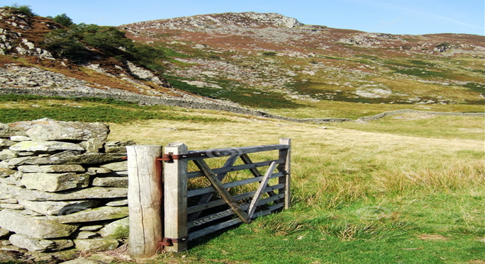  DYSGU CYMRAEG  DYSGU MWY NAG IAITH  LEARN WELSH  LEARN MORE THAN A LANGUAGE  Gwefannau defnyddiol  Useful Websites |  | ADNODDAU DYSGU CYMRAEG APP I’CH FFÔN -CLYFAR  Duolingo  SaySomething in Welsh  Caring in Welsh
Cymraeg Gwaith  Gwasanaethau Cymraeg Gwaith | Dysgu Cymraeg  Cyrsiau Blasu Ar-lein:  Mae'r cyrsiau Blasu ar-lein hyn yn wych ar gyfer dysgu geiriau ac ymadroddion sylfaenol. Maent yn rhad ac am ddim (dim ond angen creu cyfrif ar y wefan) Mae cyrsiau sydd wedi’u teilwra i feysydd gwaith penodol hefyd, e.e. Gofal neu Iechyd  Cyrsiau hunan-astudio:  Cwrs Hunan-astudio Cymraeg Gwaith | Dysgu Cymraeg  Mae’r rhain ar gael ar gyfer dysgu lefel Mynediad neu Sylfaen. Mae’r cyfan ar-lein i’w wneud pryd bynnag y bydd gennych yr amser.  Cyrsiau Codi Hyder a Defnyddio: Cyrsiau Codi Hyder a Defnyddio Nant Gwrtheyrn | Dysgu Cymraeg  Cyrsiau Codi Hyder ar gyfer dysgwyr ar lefel Canolradd, Uwch, Gloywi - Ysgrifennu a Gloywi - Siarad.  Dysgu Cymraeg Gogledd Orllewin: Croeso | Dysgu Cymraeg  Cyrsiau wythnosol dan arweiniad tiwtor: Dod o hyd i gwrs | Dysgu Cymraeg  Cyrsiau dan arweiniad tiwtor yw'r rhain a gynhelir ar-lein neu wyneb i wyneb. Byddai angen ymrwymiad wythnosol o rhwng 2-3 awr yn dibynnu ar y cwrs penodol.  Nant Gwrtheyrn: Cyrsiau Dysgu Cymraeg, Preswyl, Dwys (nantgwrtheyrn.cymru)  Cwrs dwys:  Cyrsiau Dysgu Cymraeg, Preswyl, Dwys (nantgwrtheyrn.cymru)  Mae cyrsiau ar-lein a chyrsiau preswyl wyneb i wyneb ar gael (gyda’r opsiwn i drafeilio’n ddyddiol os yn addas). Maent i gyd yn gyrsiau 5 diwrnod (Llun-Gwener). |  | Working Welsh  Work Welsh Services | Learn Welsh  Online Taster Courses:  These online Tasting courses are great for learning basic words and phrases. They are free (just need to create an account on the website) There are also courses tailored to specific areas of work, e.g. Care or Health  Self-study courses:  Work Welsh Self-Study Course | Learn Welsh  These are available for Entry or Foundation level learning. It’s all online to do whenever you have the time.  Confidence Building and Use Courses:  Nant Gwrtheyrn Confidence Building and Use Courses | Learn Welsh  Confidence Building Courses for learners at Intermediate, Advanced,  Refresher - Writing and Refresher - Speaking level.  Learn Welsh North West:  Croeso - welcome | Learn Welsh  Tutor-led weekly courses: Find a course | Learn Welsh These are tutor-led courses held online or face-to-face. A weekly commitment of between 2-3 hours would be required depending on the specific course.  Nant Gwrtheyrn:  Learn Welsh Language Courses, Residential, Intensive (nantgwrtheyrn.org)  Intensive course:  Learn Welsh Language Courses, Residential, Intensive (nantgwrtheyrn.org)  Online courses and face-to-face residential courses are available (with the option to travel daily if suitable). They are all 5 day courses (Monday-Friday).
“By enhancing the workforce’s Welsh language skills, knowledge and understanding of bilingualism, this can help deliver better care services for everyone.”  Using Welsh at work | Social Care Wales  Defnyddio’r Gymraeg yn y gweithle | Gofal Cymdeithasol Cymru |  | Mae pethau syml fel cynnig paned  yn Gymraeg yn gallu gwneud byd o  wahaniaeth i bobl yn eich gofal.  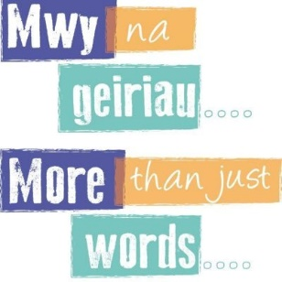  Simple things like asking people in your  care if they would like a cup of tea in Welsh  can make a huge difference to them.  ‘Paned o de?’ (‘Pan-ed or deh?’)  ‘Cup of tea?’
 |  | Actively offering Welsh language services ensures that people's needs are understood and met and that those who access care services can rely on being treated with the dignity and respect they deserve. To not actively offer Welsh language services may result in people's dignity and respect being compromised.
Mae’r wybodaeth yma ar ein gwefan |  | This information is also on our Website
Partneriaeth Datblygu'r Gweithlu (llyw.cymru) |  | Workforce Development Partnership (llyw.cymru)

