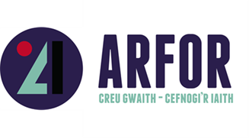
Subsidy Control

CONTROLLING THE SUBSIDIES OF STATUTORY AUTHORITIES

This grant is provided under the Minimum Financial Assistance (MFA) of the Subsidy Control Act (2022). The funding does not exceed £315,000 over a three year fiscal period as ‘Minimum Financial Assistance (MFA), in accordance with the Subsidy Control Act (2022).

Therefore, in order to confirm that you are able to access this support, as set out in section 36(1) of the Subsidy Control Act (2022) you must declare the full amount of EU State Aid de Minimus/SAFA/SPEI/MFA support you have received in the last 36 months.

All businesses / organisations seeking support will be required to acknowledge the rules and ensure that the support given under this programme does not exceed the maximum amount of support that may be given to an organisation under these regulations.

I declare that these are the sums of EU State Aid de Minimus/SAFA/SPEI/MFA support received by the organisation in the last three years (any grant offer letter will indicate what support has been given)

Year: | Year: | Year: | TOTAL
Sum: | Sum: | Sum:
Funding Body / Bodies: | Funding Body / Bodies: | Funding Body / Bodies:
Date of offer letter: | Date of offer letter: | Date of offer letter:

DECLARATION – TO BE COMPLETED BY THE APPLICANT

I declare that the information I have given is correct. I understand that I will have to repay any financial support given or that future payments will not be paid if it is found that this information is incorrect.

Business Name __________________________________________________________________

Name (PRINT) _______________________________________________________________

Signed ______________________________________________________________________

Position ____________________________________________ Date_______________________

